**--EX. 1**

-- Sa se afiseze informatiile despre produse, categoria din care fac parte si furnizorul acestora

-- B.D. este Northwind

USE Northwind

Go

SELECT TOP 10 dbo.Products.ProductID AS [Cod produs], dbo.Products.ProductName AS [Denumire produs],

dbo.Categories.CategoryName AS [Nume categorie], dbo.Suppliers.SupplierID AS [Cod furnizor],

dbo.Suppliers.ContactName AS [Nume furnizor]

FROM dbo.Categories INNER JOIN dbo.Products ON dbo.Categories.CategoryID = dbo.Products.CategoryID

INNER JOIN dbo.Suppliers ON dbo.Products.SupplierID = dbo.Suppliers.SupplierID

-- Rezultatul executiei (se afiseaza primele 10 inregistrari din cele 77 ):

***Cod produs*** ***Denumire produs*** ***Nume categorie*** ***Cod furnizor*** ***Nume furnizor***

1 Chai Beverages 1 Charlotte Cooper

2 Chang Beverages 1 Charlotte Cooper

3 Aniseed Syrup Condiments 1 Charlotte Cooper

4 Chef Anton's Cajun Seasoning Condiments 2 Shelley Burke

5 Chef Anton's Gumbo Mix Condiments 2 Shelley Burke

6 Grandma's Boysenberry Spread Condiments 3 Regina Murphy

7 Uncle Bob's Organic Dried Pears Produce 3 Regina Murphy

8 Northwoods Cranberry Sauce Condiments 3 Regina Murphy

9 Mishi Kobe Niku Meat/Poultry 4 Yoshi Nagase

10 Ikura Seafood 4 Yoshi Nagase

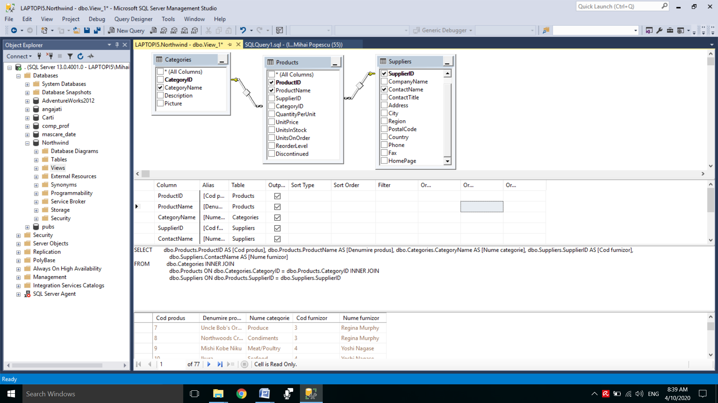

**--Ex.2**

-- Afisare informatii despre angajati, departamentul din care fac parte

-- si gradele salariale avute, in ordinea ascendenta a nr. de departament.

USE angajati

GO

SELECT TOP (100) PERCENT dbo.emp.empno AS [Cod angajat], dbo.emp.ename AS [Nume angajat],

dbo.emp.job AS Job, dbo.dept.deptno AS [Nr. depart.], dbo.dept.dname AS [Nume depart.],

dbo.salgrade.grade Grad, dbo.salgrade.losal [Val min.], dbo.salgrade.hisal [Val.max.]

FROM dbo.dept INNER JOIN dbo.emp ON dbo.dept.deptno = dbo.emp.deptno

INNER JOIN dbo.salgrade ON dbo.emp.grade = dbo.salgrade.grade

ORDER BY [Nr. depart.]

-- Rezultatul executiei :

***Cod angajat*** ***Nume angajat*** ***Job*** ***Nr. depart.*** ***Nume depart.*** ***Grad*** ***Val min.*** ***Val.max.***

7782 CLARK MANAGER 10 ACCOUNTING 4 2001 3000

7839 KING PRESIDENT 10 ACCOUNTING 5 3001 9999

7934 MILLER CLERK 10 ACCOUNTING 2 1201 1400

7902 FORD ANALYST 20 RESEARCH 4 2001 3000

7876 ADAMS CLERK 20 RESEARCH 1 700 1200

7788 SCOTT ANALYST 20 RESEARCH 4 2001 3000

7369 SMITH CLERK 20 RESEARCH 1 700 1200

7566 JONES MANAGER 20 RESEARCH 4 2001 3000

7654 MARTIN SALESMAN 30 SALES 2 1201 1400

7698 BLAKE MANAGER 30 SALES 4 2001 3000

7499 ALLEN SALESMAN 30 SALES 3 1401 2000

7521 WARD SALESMAN 30 SALES 2 1201 1400

7844 TURNER SALESMAN 30 SALES 3 1401 2000

7900 JAMES CLERK 30 SALES 1 700 1200

(14 rows affected)

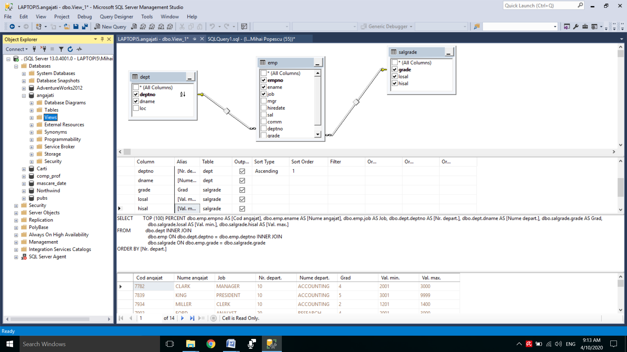

**--Ex.3**

-- Afisare nume, job, nr. departament si salariu,

-- pt. angajatii cu salariul minim pe job

USE angajati – se stabileste B.D. implicita(de lucru)

go

SELECT ename [Nume angajat], a.job, deptno [Nr. departament],sal [Salariu]

FROM emp a JOIN (select job, min(sal) minim from emp a1 group by job) sal_job

ON sal =sal_job.minim AND a.job=sal_job.job

ORDER by a.job

-- Rezultatul executiei este:

***Nume angajat*** ***job*** ***Nr. departament*** ***Salariu***

SCOTT ANALYST 20 3000.00

FORD ANALYST 20 3000.00

SMITH CLERK 20 800.00

CLARK MANAGER 10 2450.00

KING PRESIDENT 10 5000.00

WARD SALESMAN 30 1250.00

MARTIN SALESMAN 30 1250.00

(7 row(s) affected)

**--Ex.4**

--Se va lucra cu B.D. Library.

-- Se interogheaza tabelele member si adult pentru a afisa

-- informatii despre toti adultii.

--Codul generat cu designer-ul de vederi este urmatorul (vezi figura de mai jos):

SELECT a.member_no AS [Cod parinte], m.lastname AS Nume, m.firstname AS Prenume,

m.middleinitial AS [Initiala tatalui],

a.street AS Strada, a.city AS Oras, a.state AS Stat

FROM dbo.member AS m INNER JOIN dbo.adult AS a

ON m.member_no = a.member_no

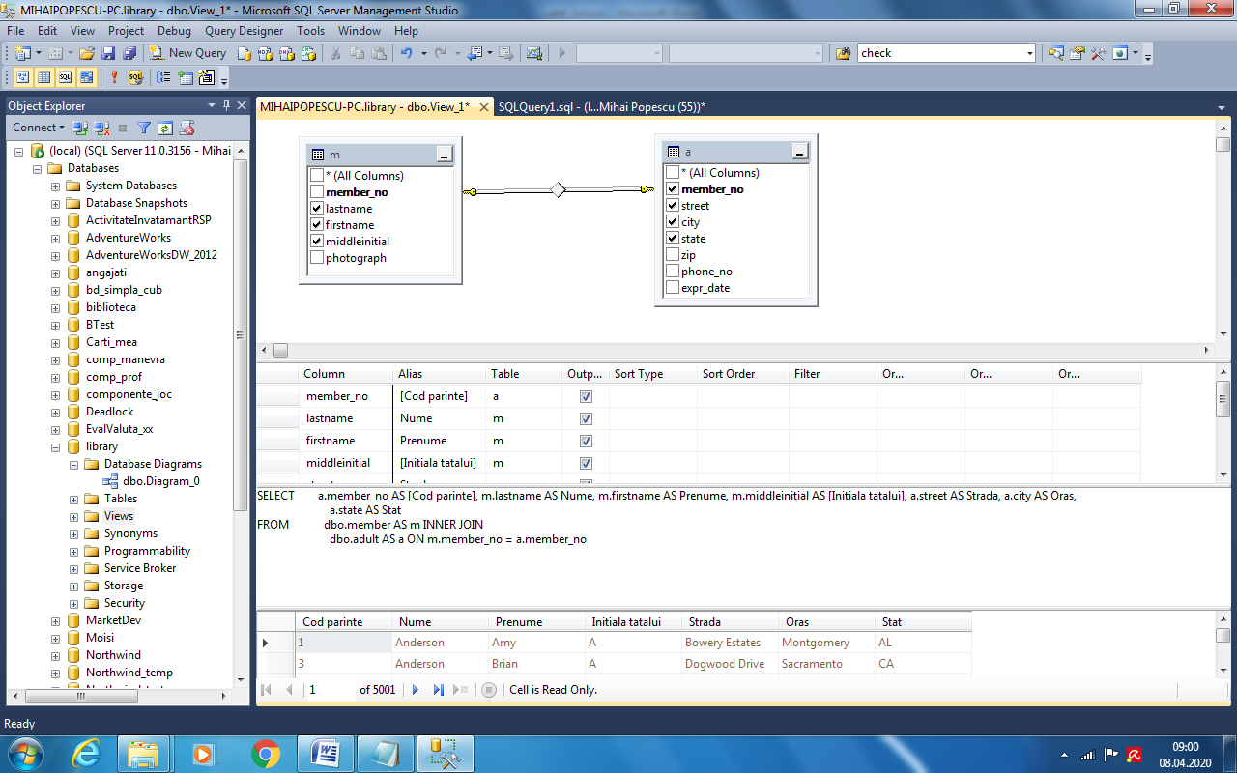

--Rezultatul executiei (pentru primele 10 linii, din 5001) este:

***Cod parinte*** ***Nume*** ***Prenume*** ***Initiala tatalui*** ***Strada*** ***Oras*** ***Stat***

1 Anderson Amy A Bowery Estates Montgomery AL

3 Anderson Brian A Dogwood Drive Sacramento CA

5 Anderson Daniel A Fir Street Washington DC

7 Anderson Eva A The Highlands Atlanta GA

9 Anderson Gary A James Road Springfield IL

11 Anderson Joshua A Larch MontRoad Boston MA

13 Anderson Katie A New Pike Road Trenton NJ

15 Anderson Mary Anne A Pine Place Albany NY

17 Anderson Monica A Race Track Road Harrisburg PA

19 Anderson Peter A Tamarack Road Salt Lake City UT

**--Ex.5**

--Se va lucra cu B.D. Library.

-- Se interogheaza tabelele member, adult si juvenile pentru a afisa

-- numele si adresa minorilor.

--Codul generat cu designer-ul de vederi este urmatorul (vezi figura de mai jos):

SELECT dbo.juvenile.member_no AS Cod, dbo.member.lastname AS Nume,

dbo.member.firstname AS Prenume, dbo.adult.street AS Strada,

dbo.adult.city AS Oras

FROM dbo.member INNER JOIN dbo.juvenile

ON dbo.member.member_no = dbo.juvenile.member_no

INNER JOIN dbo.adult

ON dbo.juvenile.adult_member_no = dbo.adult.member_no

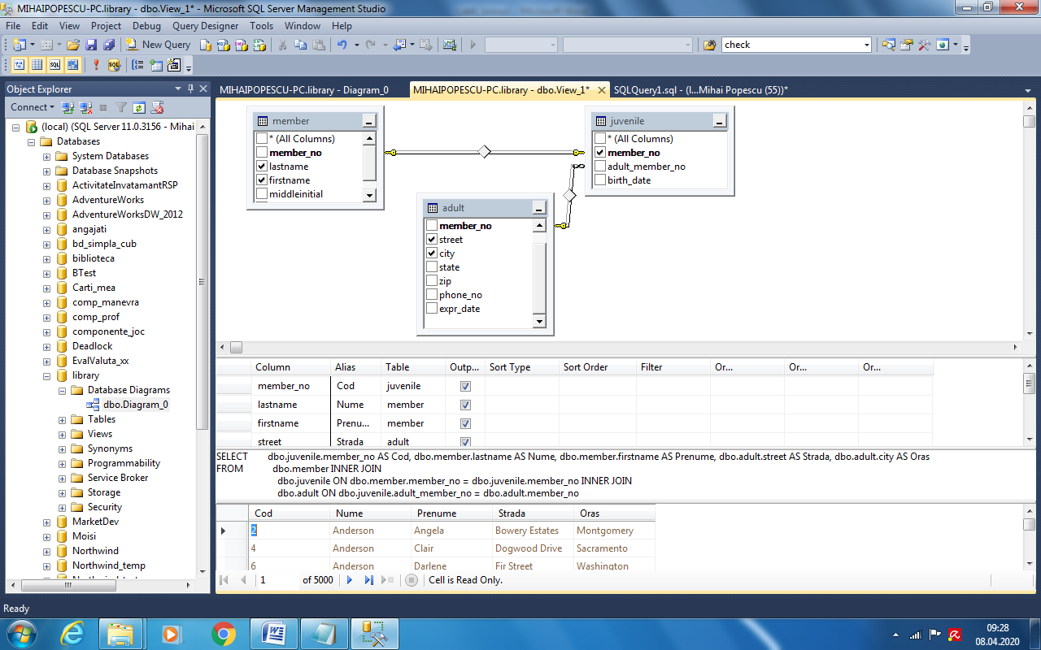

--Rezultatul executiei (pentru primele 10 linii, din 5000) este:

***Cod*** ***Nume*** ***Prenume*** ***Strada*** ***Oras***

2 Anderson Angela Bowery Estates Montgomery

4 Anderson Clair Dogwood Drive Sacramento

6 Anderson Darlene Fir Street Washington

8 Anderson Frank The Highlands Atlanta

10 Anderson Jose James Road Springfield

12 Anderson Karl Larch Mont Road Boston

14 Anderson Linda New Pike Road Trenton

16 Anderson Michael Pine Place Albany

18 Anderson Nate Race Track Road Harrisburg

20 Anderson Robert Tamarack Road Salt Lake City

**--Ex.6**

--Se va lucra cu B.D. Library.

-- Se interogheaza tabelele copy, title si item pentru a afisa

-- informatii despre fiecare copie a unei carti.

--Codul generat cu designer-ul de vederi este urmatorul (vezi figura de mai jos):

SELECT dbo.copy.isbn, dbo.copy.copy_no AS [Nr. copie], dbo.copy.on_loan AS Imprumutata,

dbo.title.title AS [Titlu carte], dbo.title.author AS Autor,

dbo.item.loanable AS Imprumutabila

FROM dbo.item INNER JOIN dbo.copy ON dbo.item.isbn = dbo.copy.isbn

INNER JOIN dbo.title ON dbo.item.title_no = dbo.title.title_no

AND dbo.copy.title_no = dbo.title.title_no

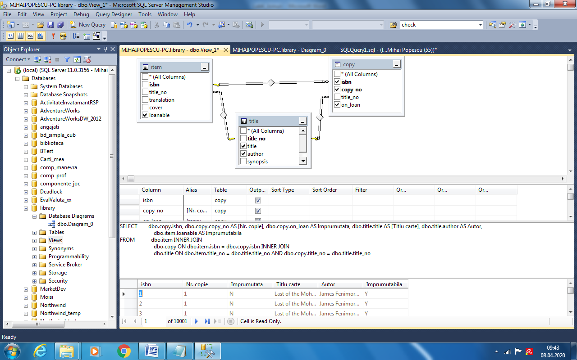

--Rezultatul executiei (pentru primele 10 linii, din 10001) este:

***Isbn Nr. copie*** ***Imprumutata*** ***Titlu carte*** ***Autor*** ***Imprumutabila***

1 1 N Last of the Mohicans James Fenimore Cooper Y

2 1 N Last of the Mohicans James Fenimore Cooper Y

3 1 N Last of the Mohicans James Fenimore Cooper Y

4 1 N Last of the Mohicans James Fenimore Cooper Y

5 1 Y Last of the Mohicans James Fenimore Cooper Y

6 1 N Last of the Mohicans James Fenimore Cooper Y

7 1 N Last of the Mohicans James Fenimore Cooper Y

8 1 N Last of the Mohicans James Fenimore Cooper Y

9 1 N Last of the Mohicans James Fenimore Cooper Y

10 1 Y Last of the Mohicans James Fenimore Cooper Y

**--Ex.7**

--Se va lucra cu B.D. Library.

-- Se interogheaza tabelele loan, title si member pentru a afisa

-- campurile member, title si loan despre fiecare copie a unei carti.

--Codul generat cu designer-ul de vederi este urmatorul (vezi figura de mai jos):

SELECT dbo.loan.out_date AS [Data Impr.], dbo.loan.due_date AS [Data rest.],

dbo.loan.isbn, dbo.loan.copy_no AS [Nr. copie], dbo.title.title AS Titlu,

dbo.member.lastname AS [Nume membru], dbo.member.firstname AS [Prenume membru]

FROM dbo.member INNER JOIN dbo.loan ON dbo.member.member_no = dbo.loan.member_no

INNER JOIN dbo.title ON dbo.loan.title_no = dbo.title.title_no

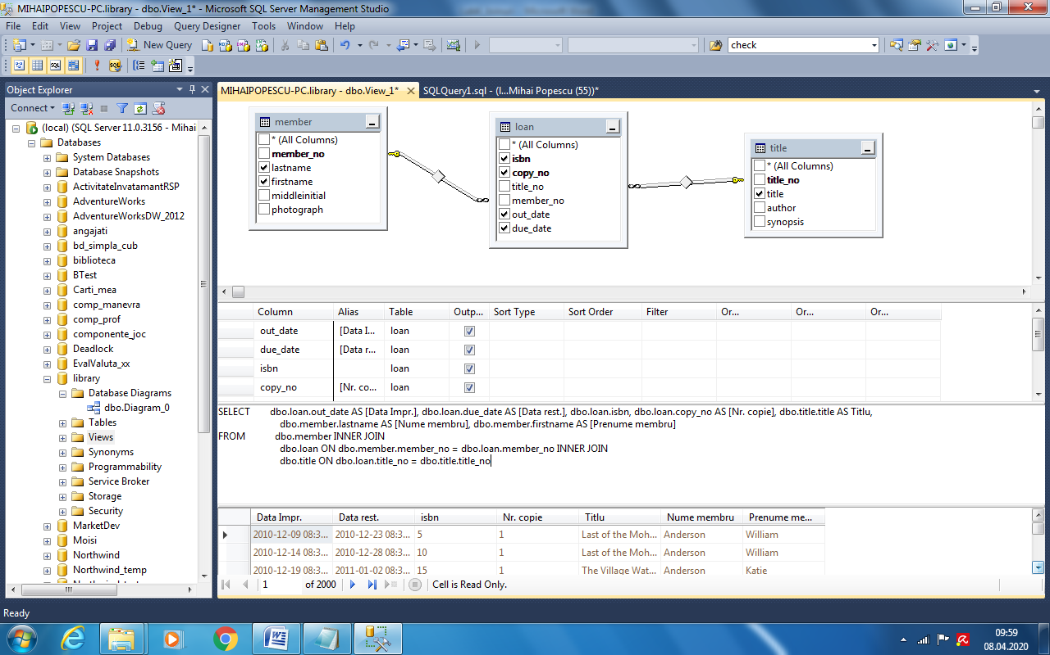

--Rezultatul executiei (pentru primele 20 linii, din 2000) este:

***Data Impr.*** ***Data rest.*** ***isbn*** ***Nr. copie*** ***Titlu*** ***Nume membru*** ***Prenume membru***

2010-12-09 08:33:07.967 2010-12-23 08:33:07.967 5 1 Last of the Mohicans Anderson William

2010-12-14 08:33:07.967 2010-12-28 08:33:07.967 10 1 Last of the Mohicans Anderson William

2010-12-19 08:33:07.967 2011-01-02 08:33:07.967 15 1 The Village Watch-Tower Anderson Katie

2010-12-08 08:33:07.967 2010-12-22 08:33:07.967 20 1 The Village Watch-Tower Anderson Katie

2010-12-13 08:33:07.967 2010-12-27 08:33:07.967 25 1 Self Help; Conduct & Perseverance Anderson William

2010-12-18 08:33:07.967 2011-01-01 08:33:07.967 30 1 Self Help; Conduct & Perseverance Anderson William

2010-12-07 08:33:07.967 2010-12-21 08:33:07.967 35 1 Songs of a Savoyard Anderson Katie

2010-12-12 08:33:07.967 2010-12-26 08:33:07.967 40 1 Songs of a Savoyard Anderson Katie

2010-12-17 08:33:07.967 2010-12-31 08:33:07.967 45 1 Fall of the House of Usher Anderson William

2010-12-06 08:33:07.967 2010-12-20 08:33:07.967 50 1 Fall of the House of Usher Anderson William

2010-12-12 08:33:07.967 2010-12-26 08:33:07.967 4 2 Last of the Mohicans Anderson Katie

2010-12-06 08:33:07.967 2010-12-20 08:33:07.967 9 2 Last of the Mohicans Anderson Katie

2010-12-11 08:33:07.967 2010-12-25 08:33:07.967 55 1 The Cook's Decameron Anderson Katie

2010-12-16 08:33:07.967 2010-12-30 08:33:07.967 60 1 The Cook's Decameron Barr Katie

2010-12-16 08:33:07.967 2010-12-30 08:33:07.967 14 2 The Village Watch-Tower Barr William

2010-12-10 08:33:07.967 2010-12-24 08:33:07.967 19 2 The Village Watch-Tower Barr William

2010-12-05 08:33:07.967 2010-12-19 08:33:07.967 65 1 Poems Barr William

2010-12-10 08:33:07.967 2010-12-24 08:33:07.967 70 1 Poems Barr William

2010-12-04 08:33:07.967 2010-12-18 08:33:07.967 24 2 Self Help; Conduct & Perseverance Barr Katie

2010-12-14 08:33:07.967 2010-12-28 08:33:07.967 29 2 Self Help; Conduct & Perseverance Barr Katie

**--Ex.8**

--Se va lucra cu B.D. Library.

-- 8.1 Se interogheaza tabelele member, adult si juvenile pentru a afisa

-- membrii din statul Arizona cu mai mult de doi copii .

--Codul generat cu designer-ul de vederi este urmatorul (vezi figura de mai jos):

SELECT dbo.adult.member_no AS [Cod adult], dbo.member.lastname AS [Nume adult],

dbo.member.firstname AS [Prenume adult], COUNT(*) AS [Nr. copii]

FROM dbo.adult INNER JOIN dbo.juvenile ON dbo.adult.member_no = dbo.juvenile.adult_member_no

INNER JOIN dbo.member ON dbo.adult.member_no = dbo.member.member_no

WHERE (dbo.adult.state = 'AZ')

GROUP BY dbo.adult.member_no, dbo.member.lastname, dbo.member.firstname

HAVING (COUNT(*) > 2)

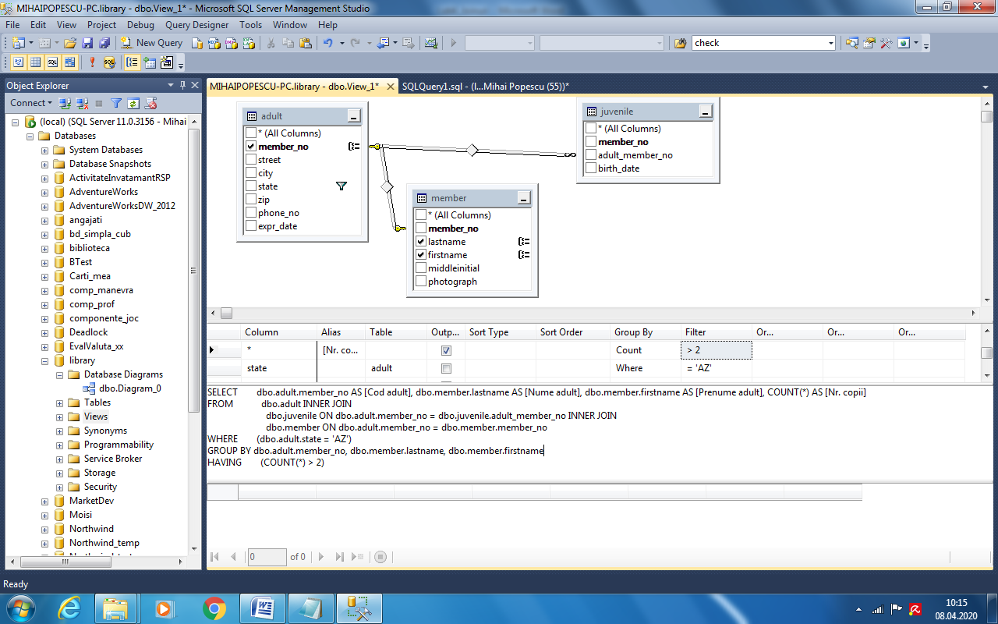

--Rezultatul executiei este (21 membri):

***Cod adult Nume adult*** ***Prenume adult*** ***Nr. copii***

25 Anderson Thom 4

71 Anderson Peter 4

117 Anderson Katie 4

163 Anderson Eva 4

209 Anderson Amy 4

255 Anderson Sarah 4

301 Anderson Mary Anne 4

347 Anderson Gary 4

393 Anderson Brian 4

439 Anderson Stephen 4

485 Anderson Monica 4

531 Anderson Joshua 3

577 Anderson Daniel 3

623 Anderson Thom 3

669 Anderson Peter 3

715 Barr Katie 3

761 Barr Eva 3

807 Barr Amy 3

853 Barr Sarah 3

899 Barr Mary Anne 3

945 Barr Gary 3

-- 8.2 Se interogheaza tabelele member, adult si juvenile pentru a afisa

-- membrii din statul California cu mai mult de trei copii .

--Codul generat cu designer-ul de vederi este urmatorul:

SELECT dbo.adult.member_no AS [Cod adult], dbo.member.lastname AS [Nume adult],

dbo.member.firstname AS [Prenume adult], COUNT(*) AS [Nr. copii]

FROM dbo.adult INNER JOIN dbo.juvenile ON dbo.adult.member_no = dbo.juvenile.adult_member_no

INNER JOIN dbo.member ON dbo.adult.member_no = dbo.member.member_no

WHERE (dbo.adult.state = 'CA')

GROUP BY dbo.adult.member_no, dbo.member.lastname, dbo.member.firstname

HAVING (COUNT(*) > 3)

--Rezultatul executiei este (11 membri):

***Cod adult Nume adult*** ***Prenume adult*** ***Nr. copii***

3 Anderson Brian 4

49 Anderson Stephen 4

95 Anderson Monica 4

141 Anderson Joshua 4

187 Anderson Daniel 4

233 Anderson Thom 4

279 Anderson Peter 4

325 Anderson Katie 4

371 Anderson Eva 4

417 Anderson Amy 4

463 Anderson Sarah 4

-- 8.3 Se interogheaza tabelele member, adult si juvenile pentru a afisa

-- membrii din statul Arizona cu mai mult de doi copii si din statul California cu mai mult de trei copii,

-- in ordinea ascendenta a statului .

--Codul generat cu designer-ul de vederi este urmatorul:

SELECT dbo.adult.member_no AS [Cod adult], dbo.member.lastname AS [Nume adult],

dbo.member.firstname AS [Prenume adult], COUNT(*) AS [Nr. copii],state [Stat]

FROM dbo.adult INNER JOIN dbo.juvenile ON dbo.adult.member_no = dbo.juvenile.adult_member_no

INNER JOIN dbo.member ON dbo.adult.member_no = dbo.member.member_no

WHERE (dbo.adult.state = 'AZ')

GROUP BY dbo.adult.member_no, dbo.member.lastname, dbo.member.firstname,state

HAVING (COUNT(*) > 2)

UNION

SELECT dbo.adult.member_no AS [Cod adult], dbo.member.lastname AS [Nume adult],

dbo.member.firstname AS [Prenume adult], COUNT(*) AS [Nr. copii],state

FROM dbo.adult INNER JOIN dbo.juvenile ON dbo.adult.member_no = dbo.juvenile.adult_member_no

INNER JOIN dbo.member ON dbo.adult.member_no = dbo.member.member_no

WHERE (dbo.adult.state = 'CA')

GROUP BY dbo.adult.member_no, dbo.member.lastname, dbo.member.firstname,state

HAVING (COUNT(*) > 3)

ORDER BY adult.state

--Rezultatul executiei este(32 membri:21 + 11):

***Cod adult*** ***Nume adult*** ***Prenume adult*** ***Nr. copii*** ***Stat***

25 Anderson Thom 4 AZ

71 Anderson Peter 4 AZ

117 Anderson Katie 4 AZ

163 Anderson Eva 4 AZ

209 Anderson Amy 4 AZ

255 Anderson Sarah 4 AZ

301 Anderson Mary Anne 4 AZ

347 Anderson Gary 4 AZ

393 Anderson Brian 4 AZ

439 Anderson Stephen 4 AZ

485 Anderson Monica 4 AZ

531 Anderson Joshua 3 AZ

577 Anderson Daniel 3 AZ

623 Anderson Thom 3 AZ

669 Anderson Peter 3 AZ

715 Barr Katie 3 AZ

761 Barr Eva 3 AZ

807 Barr Amy 3 AZ

853 Barr Sarah 3 AZ

899 Barr Mary Anne 3 AZ

945 Barr Gary 3 AZ

3 Anderson Brian 4 CA

49 Anderson Stephen 4 CA

95 Anderson Monica 4 CA

141 Anderson Joshua 4 CA

187 Anderson Daniel 4 CA

233 Anderson Thom 4 CA

279 Anderson Peter 4 CA

325 Anderson Katie 4 CA

371 Anderson Eva 4 CA

417 Anderson Amy 4 CA

463 Anderson Sarah 4 CA

**--Ex.9**

--Se va lucra cu B.D. Library.

-- Se vor afisa i-tii despre adulti si copiii pe care-I gireaza,

-- folosind dubla instantiere pentru tabela member.

SELECT TOP 20 dbo.member.member_no [Cod copil],dbo.member.lastname AS [Nume copil], dbo.member.firstname AS [Prenume copil],

member_1.member_no [Cod parinte], member_1.lastname AS [Nume parinte], member_1.firstname AS [Prenume parinte]

FROM dbo.adult INNER JOIN dbo.juvenile ON dbo.adult.member_no = dbo.juvenile.adult_member_no

INNER JOIN dbo.member ON dbo.juvenile.member_no = dbo.member.member_no

INNER JOIN dbo.member AS member_1 ON dbo.adult.member_no = member_1.member_no

ORDER BY [cod parinte],[Nume parinte], [Prenume parinte]

--Rezultatul este (primele 20 inregistrari, din 5000):

***Cod copil*** ***Nume copil*** ***Prenume copil*** ***Cod parinte*** ***Nume parinte*** ***Prenume parinte***

7126 Jones Angela 1 Anderson Amy

8524 LaBrie Shelly 1 Anderson Amy

9506 Miksovsky Michael 1 Anderson Amy

2 Anderson Angela 1 Anderson Amy

7128 Jones Clair 3 Anderson Brian

8526 LaBrie Teresa 3 Anderson Brian

9508 Miksovsky Nate 3 Anderson Brian

4 Anderson Clair 3 Anderson Brian

7130 Jones Darlene 5 Anderson Daniel

8528 LaBrie William 5 Anderson Daniel

9510 Miksovsky Robert 5 Anderson Daniel

6 Anderson Darlene 5 Anderson Daniel

7132 Jones Frank 7 Anderson Eva

8530 LaBrie Angela 7 Anderson Eva

9512 Miksovsky Shelly 7 Anderson Eva

8 Anderson Frank 7 Anderson Eva

7134 Jones Jose 9 Anderson Gary

8532 LaBrie Clair 9 Anderson Gary

9514 Miksovsky Teresa 9 Anderson Gary

10 Anderson Jose 9 Anderson Gary